1. Introduction
Potholes represent one of the most persistent hazards on road infrastructure, contributing to vehicle damage, traffic accidents, and costly maintenance operations. Manual inspection of roads is slow, expensive, and inconsistent. An automated system capable of detecting and precisely delineating pothole boundaries in real time would greatly aid transportation departments in prioritising repairs and improving public safety.

This project addresses this challenge by training a YOLOv8 instance segmentation model on a curated dataset of annotated road images. The work spans the entire machine learning pipeline: data ingestion and verification, a classical computer vision baseline for comparison, deep model training on GPU, quantitative evaluation using standard COCO metrics, visual inspection of predictions on unseen images, and deployment of a real-time webcam inference script.

The remainder of the report is organised as follows. Section 2 describes the dataset. Section 3 covers the environment setup. Section 4 presents a traditional CV baseline. Section 5 details the model architecture and training. Section 6 evaluates the model quantitatively. Section 7 shows qualitative predictions. Section 8 presents the real-time deployment script. Section 9 discusses the results, and Section 10 concludes.

2. Dataset
The dataset used in this project is the Pothole Segmentation YOLOv8 dataset, sourced from Roboflow Universe (https://universe.roboflow.com/farzad/pothole_segmentation_yolov8). It contains annotated real-world road photographs targeting the single class "pothole".

2.1 Dataset Statistics
Split | Images | Labels | Backgrounds | Corrupt
Training | 720 | 720 | 0 | 0
Validation | 60 | 60 | 0 | 0
Total | 780 | 780 | 0 | 0

2.2 Pre-processing
Every image in the dataset was processed through the following standardised steps before being fed into the model:

- Auto-orientation of pixel data with EXIF-orientation stripping to ensure consistent image rotation.
- Resizing to a fixed resolution of 640×640 pixels using stretch interpolation to fill the full square input expected by YOLOv8.

2.3 Augmentation
To increase training data diversity and reduce overfitting, each source image in the training split was augmented to produce 3 versions. The augmentation pipeline applied the following transformations exclusively to training images:

- Horizontal flip with a 50% probability.
- Random cropping between 0% and 20% of the image area.
- Random rotation between −15° and +15°.
- Random shearing of −5° to +5° horizontally and vertically.
- Random brightness adjustment of ±25%.
- Random exposure adjustment of ±25%.
- Additional albumentations applied at runtime: Blur, MedianBlur, ToGray (1% probability each), and CLAHE (1%).

2.4 Dataset Verification Code
Code — Dataset setup and verification:

import os
import glob
import cv2
import torch
import matplotlib.pyplot as plt
from ultralytics import YOLO

print('Libraries imported successfully.')
print('CUDA Available:', torch.cuda.is_available())

if torch.cuda.is_available():
print('GPU:', torch.cuda.get_device_name(0))
DEVICE = 0
else:
print('GPU is not enabled. Training will be slow.')
DEVICE = 'cpu'

Output:
Libraries imported successfully.
CUDA Available: True
GPU: Tesla T4

DATASET_PATH = '/kaggle/input/datasets/farzadnekouei/pothole-image-segmentation-dataset/'
+ 'Pothole_Segmentation_YOLOv8'

train_images = glob.glob(f'{DATASET_PATH}/train/images/*')
train_labels = glob.glob(f'{DATASET_PATH}/train/labels/*')
valid_images = glob.glob(f'{DATASET_PATH}/valid/images/*')
valid_labels = glob.glob(f'{DATASET_PATH}/valid/labels/*')

print('Training images:', len(train_images))
print('Training labels:', len(train_labels))
print('Validation images:', len(valid_images))
print('Validation labels:', len(valid_labels))

Output:
Dataset path exists: True
Files inside dataset: ['README.dataset.txt', 'README.roboflow.txt',
'data.yaml', 'valid', 'sample_video.mp4', 'train']
Training images: 720 Training labels: 720
Validation images: 60 Validation labels: 60

2.5 YAML Configuration
YOLOv8 requires a YAML configuration file specifying dataset paths and class names. The file was generated programmatically:

YAML_PATH = '/kaggle/working/pothole_dataset.yaml'

yaml_content = f'''
path: {DATASET_PATH}
train: train/images
val: valid/images

names:
0: pothole
'''

with open(YAML_PATH, 'w') as f:
f.write(yaml_content)

2.6 Sample Image

sample_image_path = train_images[0]
image = cv2.imread(sample_image_path)
image = cv2.cvtColor(image, cv2.COLOR_BGR2RGB)
plt.figure(figsize=(8, 6))
plt.imshow(image)
plt.axis('off')
plt.title('Sample Road Image')
plt.show()

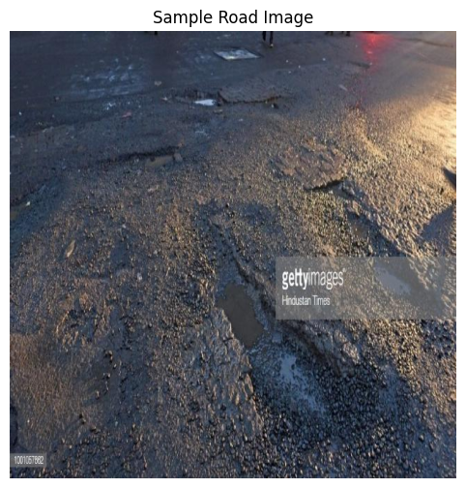
Figure 1: A representative sample image from the training set showing a road with pothole(s).

3. Environment & Setup
The project was executed on Kaggle Notebooks with GPU acceleration enabled. The Ultralytics library was installed at the start of the session.

Component | Details
Platform | Kaggle Notebooks
GPU | Tesla T4 (14,913 MiB VRAM)
Python | 3.12.12
PyTorch | 2.10.0+cu128
CUDA | Available (cu128)
Ultralytics | 8.4.50
Model Base | YOLOv8n-seg (nano segmentation variant)
Image Size | 640 × 640 pixels

Installation:

!pip install ultralytics -q

4. Traditional Computer Vision Baseline
Before training a neural network, a classical computer vision pipeline was implemented and applied to a sample image. This establishes a qualitative baseline and illustrates the limitations of handcrafted approaches for pothole detection.

4.1 Pipeline Description
The pipeline applies the following stages sequentially:

- Grayscale conversion — removes colour information, reducing processing complexity.
- Gaussian blur (5×5 kernel, σ=0) — suppresses high-frequency noise while preserving structural edges.
- Canny edge detection (low threshold: 50, high threshold: 150) — extracts significant gradient transitions corresponding to surface discontinuities.
- Morphological closing (5×5 rectangular kernel) — connects nearby edge fragments to form closed regions.
- Contour detection and bounding box annotation — contours with area > 300 px² are enclosed in green rectangles.

4.2 Implementation

def traditional_cv_pothole_detection(image_path):
image = cv2.imread(image_path)
original = cv2.cvtColor(image, cv2.COLOR_BGR2RGB)
gray = cv2.cvtColor(image, cv2.COLOR_BGR2GRAY)
blur = cv2.GaussianBlur(gray, (5, 5), 0)
edges = cv2.Canny(blur, 50, 150)

kernel = cv2.getStructuringElement(cv2.MORPH_RECT, (5, 5))
closed = cv2.morphologyEx(edges, cv2.MORPH_CLOSE, kernel)

contours, _ = cv2.findContours(
closed, cv2.RETR_EXTERNAL, cv2.CHAIN_APPROX_SIMPLE
)
output = image.copy()

for contour in contours:
area = cv2.contourArea(contour)
if area > 300:
x, y, w, h = cv2.boundingRect(contour)
cv2.rectangle(output, (x, y), (x + w, y + h), (0, 255, 0), 2)

output = cv2.cvtColor(output, cv2.COLOR_BGR2RGB)

plt.figure(figsize=(16, 8))
plt.subplot(1, 3, 1); plt.imshow(original); plt.title('Original Image'); plt.axis('off')
plt.subplot(1, 3, 2); plt.imshow(edges, cmap='gray'); plt.title('Canny Edge Detection'); plt.axis('off')
plt.subplot(1, 3, 3); plt.imshow(output); plt.title('Traditional CV Output'); plt.axis('off')
plt.show()

traditional_cv_pothole_detection(sample_image_path)

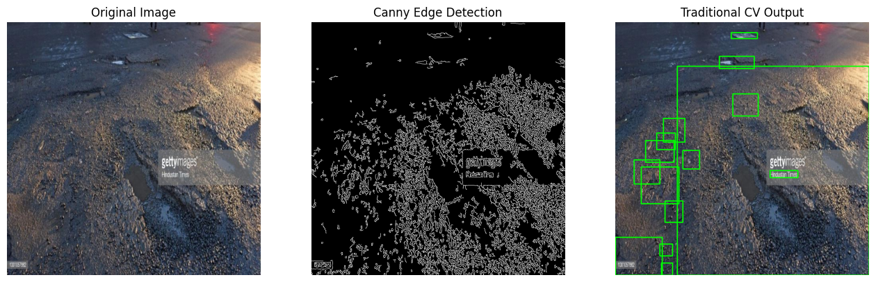
Figure 2: Traditional CV pipeline — (left) original image, (centre) Canny edges, (right) bounding box detections.

4.3 Limitations
While the traditional approach partially highlights surface discontinuities, it exhibits several critical shortcomings:
- High false-positive rate: textures, road markings, shadows, and lighting variations all generate spurious detections.
- No semantic understanding: the pipeline cannot distinguish a pothole from any other textured region with strong edges.
- Bounding boxes only: no pixel-level segmentation mask can be produced, making area estimation unreliable.
- Sensitivity to parameters: the Canny thresholds and contour area cutoff require manual tuning per scene.
These limitations motivate the use of a learned, end-to-end segmentation model.

5. Model Architecture & Training

5.1 YOLOv8n-seg Architecture
YOLOv8 (You Only Look Once, version 8) is a single-stage object detection and segmentation framework developed by Ultralytics. The nano variant (YOLOv8n-seg) was chosen for this project to balance detection quality with inference speed, making it suitable for real-time deployment.

Property | Value
Total Layers | 152 (training) / 86 (fused inference)
Parameters | 3,263,811 (training) / 3,258,259 (fused)
Gradients | 3,263,795
Compute (GFLOPs) | 11.5 (training) / 11.3 (fused)
Model Size | 6.8 MB (stripped best.pt)
Pre-trained On | COCO (80-class detection weights, adapted to 1 class)
Head | Segment head with 32 mask prototypes

The architecture consists of a CSPDarknet backbone with C2f bottleneck blocks, an FPN neck (SPPF + upsampling), and a detection/segmentation head that simultaneously predicts bounding boxes and pixel masks. Pretrained COCO weights are transferred (381/417 items), and the classification head is re-initialised for the single pothole class.

5.2 Training Configuration
Parameter | Value
Epochs | 30
Image Size | 640 × 640
Batch Size | 8
Optimizer | AdamW (auto-selected)
Learning Rate | lr0 = 0.002, lrf = 0.01
Momentum | 0.9
Weight Decay | 0.0005
AMP | Enabled (Automatic Mixed Precision)
Warmup Epochs | 3
Close Mosaic | Last 10 epochs
Device | CUDA:0 (Tesla T4)
Workers | 2 dataloader workers
Training Time | 0.121 hours (~7.3 minutes)

5.3 Training Code

model = YOLO('yolov8n-seg.pt') # Load pretrained nano-seg weights

results = model.train(
data = YAML_PATH,
epochs = 30,
imgsz = 640,
batch = 8,
device = DEVICE,
project = '/kaggle/working/runs',
name = 'pothole_segmentation_model'
)
print('Training completed.')

5.4 Training Log (All 30 Epochs)
The table below records validation metrics at the end of each epoch. All values are on the 60-image validation set.

Epoch | box_loss | seg_loss | cls_loss | Box mAP50 | Mask mAP50
1 | 1.476 | 2.845 | 2.272 | 0.203 | 0.196
2 | 1.537 | 2.609 | 1.868 | 0.500 | 0.507
3 | 1.504 | 2.536 | 1.762 | 0.234 | 0.226
4 | 1.519 | 2.495 | 1.704 | 0.390 | 0.380
5 | 1.503 | 2.502 | 1.638 | 0.541 | 0.470
6 | 1.448 | 2.372 | 1.512 | 0.517 | 0.522
7 | 1.467 | 2.387 | 1.489 | 0.566 | 0.585
8 | 1.428 | 2.284 | 1.393 | 0.620 | 0.639
9 | 1.366 | 2.255 | 1.353 | 0.528 | 0.527
10 | 1.342 | 2.171 | 1.317 | 0.604 | 0.624
11 | 1.317 | 2.145 | 1.288 | 0.624 | 0.630
12 | 1.299 | 2.089 | 1.227 | 0.633 | 0.642
13 | 1.287 | 2.080 | 1.196 | 0.640 | 0.647
14 | 1.260 | 2.051 | 1.137 | 0.656 | 0.645
15 | 1.271 | 2.053 | 1.150 | 0.692 | 0.696
16 | 1.205 | 1.941 | 1.052 | 0.688 | 0.689
17 | 1.212 | 1.968 | 1.081 | 0.656 | 0.697
18 | 1.183 | 1.925 | 1.038 | 0.690 | 0.702
19 | 1.182 | 1.943 | 1.020 | 0.632 | 0.641
20 | 1.151 | 1.871 | 0.990 | 0.697 | 0.709
21 | 1.151 | 1.815 | 0.929 | 0.658 | 0.652
22 | 1.108 | 1.787 | 0.872 | 0.697 | 0.705
23 | 1.089 | 1.707 | 0.836 | 0.666 | 0.672
24 | 1.067 | 1.686 | 0.802 | 0.703 | 0.712
25 | 1.061 | 1.659 | 0.782 | 0.693 | 0.698
26 | 1.022 | 1.630 | 0.757 | 0.686 | 0.696
27 | 0.990 | 1.581 | 0.708 | 0.676 | 0.710
28 | 0.978 | 1.579 | 0.700 | 0.697 | 0.713
29 | 0.958 | 1.567 | 0.679 | 0.688 | 0.719
30 | 0.943 | 1.566 | 0.663 | 0.691 | 0.720

Training log summary (final epoch):
30 epochs completed in 0.121 hours.
Optimizer stripped from .../weights/last.pt, 6.8MB
Optimizer stripped from .../weights/best.pt, 6.8MB

Best model validation summary:
Class Images Instances Box(P R mAP50 mAP50-95) Mask(P R mAP50 mAP50-95)
all 60 201 0.689 0.657 0.688 0.429 0.710 0.677 0.717 0.414
Speed: 0.4ms preprocess | 5.4ms inference | 5.4ms postprocess

5.5 Training Curves

results_graph_path = '/kaggle/working/runs/pothole_segmentation_model/results.png'
img = cv2.imread(results_graph_path)
img = cv2.cvtColor(img, cv2.COLOR_BGR2RGB)
plt.figure(figsize=(12, 8))
plt.imshow(img); plt.axis('off'); plt.title('Training Results'); plt.show()

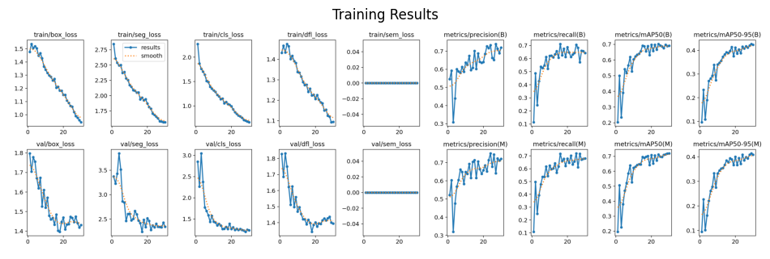
Figure 3: Training curves showing box loss, segmentation loss, classification loss, and mAP metrics across 30 epochs.

6. Model Evaluation
After training, the best checkpoint (best.pt, saved at epoch 29 with highest mask mAP50 = 0.719) was reloaded and evaluated on the 60-image validation set using the standard COCO evaluation protocol.

6.1 Evaluation Code

best_model_path = '/kaggle/working/runs/pothole_segmentation_model/weights/best.pt'
trained_model = YOLO(best_model_path)

metrics = trained_model.val(
data = YAML_PATH,
imgsz = 640,
batch = 8,
device = DEVICE
)

print('Evaluation Results')
print('------------------')
print('Box mAP50: ', metrics.box.map50)
print('Box mAP50-95:', metrics.box.map)
print('Mask mAP50: ', metrics.seg.map50)
print('Mask mAP50-95:', metrics.seg.map)

Output:
YOLOv8n-seg summary (fused): 86 layers, 3,258,259 parameters, 11.3 GFLOPs
val: 60 images, 0 backgrounds, 0 corrupt scanned successfully.

Class Images Instances Box(P R mAP50 mAP50-95) Mask(P R mAP50 mAP50-95)
all 60 201 0.690 0.657 0.689 0.428 0.712 0.677 0.719 0.410

Speed: 3.5ms preprocess | 10.2ms inference | 5.2ms postprocess per image

Evaluation Results
------------------
Box mAP50: 0.6887827303393769
Box mAP50-95: 0.42839074996724424
Mask mAP50: 0.7186284461536584
Mask mAP50-95: 0.410359244989157

6.2 Results Summary
Task | Precision | Recall | mAP@50 | mAP@50-95
Bounding Box | 0.690 | 0.657 | 0.689 | 0.428
Instance Segmentation | 0.712 | 0.677 | 0.719 | 0.410

Key observations:
- The segmentation mask mAP50 of 0.719 surpasses the bounding box mAP50 of 0.689, suggesting the model learns precise pixel-level boundaries rather than just coarse box localisations.
- Precision (0.712) slightly exceeds recall (0.677) for masks, indicating the model is conservative — when it predicts a pothole, it is usually correct, though some instances are missed.
- The mAP50-95 scores (~0.41) reflect the difficulty of achieving tight IoU at higher thresholds — expected for small, irregular-shaped potholes.
- These results are competitive for a nano model trained for only 30 epochs, without hyperparameter tuning.

6.3 Confusion Matrix

confusion_matrix_path = '/kaggle/working/runs/pothole_segmentation_model/confusion_matrix.png'
img = cv2.imread(confusion_matrix_path)
img = cv2.cvtColor(img, cv2.COLOR_BGR2RGB)
plt.figure(figsize=(8, 6))
plt.imshow(img); plt.axis('off'); plt.title('Confusion Matrix'); plt.show()

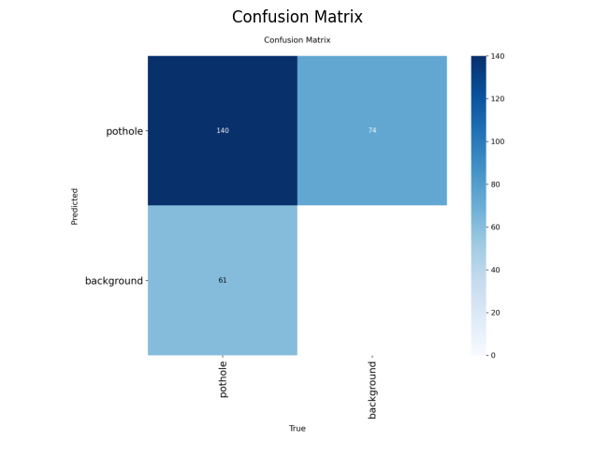
Figure 4: Normalised confusion matrix on the validation set. Rows = ground truth, Columns = predicted.

7. Predictions on Unseen Validation Images
The trained model was used to run inference on 5 images from the validation set that were not used during training. Predictions were saved with segmentation masks and confidence scores overlaid.

7.1 Prediction Code

test_images = valid_images[:5]

trained_model.predict(
source = test_images,
conf = 0.25,
save = True,
project = '/kaggle/working/runs',
name = 'unseen_predictions'
)
print('Prediction completed.')

Output:
0: 640x640 3 potholes, 12.3ms
1: 640x640 15 potholes, 12.3ms
2: 640x640 1 pothole, 12.3ms
3: 640x640 2 potholes, 12.3ms
4: 640x640 3 potholes, 12.3ms
Speed: 2.0ms preprocess | 12.3ms inference | 3.8ms postprocess
Results saved to /kaggle/working/runs/unseen_predictions
Prediction completed.

7.2 Prediction Visualisations

predicted_images = glob.glob('/kaggle/working/runs/unseen_predictions/*')
for img_path in predicted_images[:5]:
img = cv2.cvtColor(cv2.imread(img_path), cv2.COLOR_BGR2RGB)
plt.figure(figsize=(8, 6))
plt.imshow(img); plt.axis('off')
plt.title('YOLOv8 Pothole Segmentation Prediction')
plt.show()

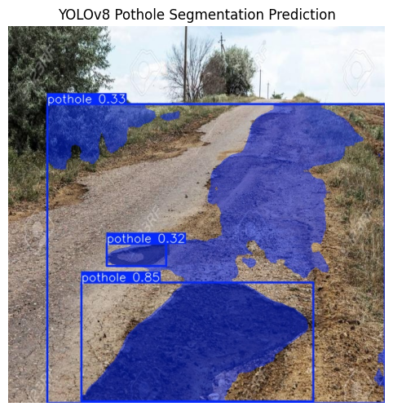
Figure 5a: Prediction 1 — 3 potholes detected with segmentation masks.
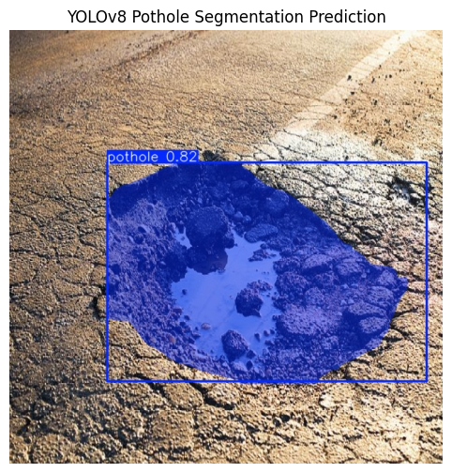
Figure 5b: Prediction 2 — 15 potholes detected. Dense pothole scene.
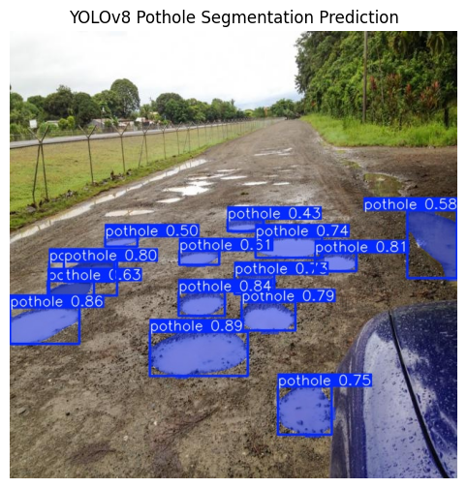
Figure 5c: Prediction 3 — 1 pothole detected.
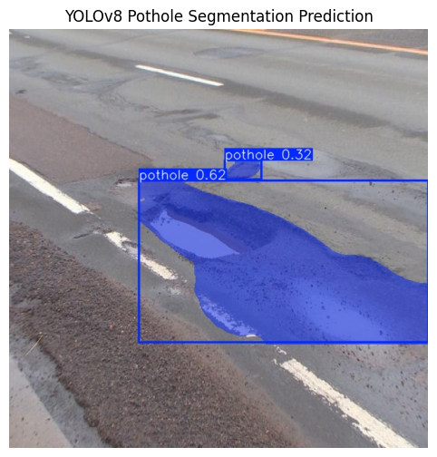
Figure 5d: Prediction 4 — 2 potholes detected.
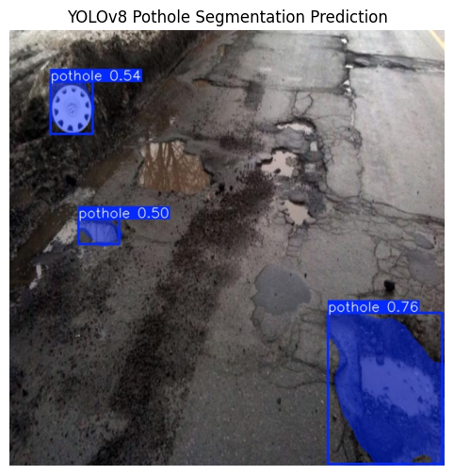
Figure 5e: Prediction 5 — 3 potholes detected.

8. Real-Time Pothole Detection (Webcam)
To demonstrate deployment capability, a standalone Python script (Road_Detection.py) was developed. It loads the trained best.pt weights and performs live pothole segmentation on a webcam feed, overlaying prediction masks and displaying the current frame-per-second (FPS) rate.

8.1 Implementation

from ultralytics import YOLO
import cv2, time, os

MODEL_PATH = 'CV_Project/best.pt'

if not os.path.exists(MODEL_PATH):
print('Error: best.pt not found.')
print('Place best.pt in the same folder as this Python file.')
exit()

model = YOLO(MODEL_PATH)
print('Model loaded successfully.')

cap = cv2.VideoCapture(0)

if not cap.isOpened():
print('Could not open webcam.')
print('Try changing cv2.VideoCapture(0) to cv2.VideoCapture(1).')
exit()

print('Webcam opened successfully.')
print("Press 'q' to quit.")

prev_time = 0

while True:
ret, frame = cap.read()
if not ret:
print('Could not read frame from webcam.')
break

results = model.predict(
source = frame,
conf = 0.25,
imgsz = 640,
verbose = False
)

annotated_frame = results[0].plot()

current_time = time.time()
fps = 1 / (current_time - prev_time) if prev_time != 0 else 0
prev_time = current_time

cv2.putText(
annotated_frame,
f'FPS: {fps:.2f}',
(20, 40),
cv2.FONT_HERSHEY_SIMPLEX,
1, (0, 255, 0), 2
)

cv2.imshow('Real-Time Pothole Detection', annotated_frame)

if cv2.waitKey(1) & 0xFF == ord('q'):
break

cap.release()
cv2.destroyAllWindows()

8.2 How to Run
- Place best.pt inside a folder named CV_Project/ in the same directory as Road_Detection.py.
- Run the script: python Road_Detection.py
- The webcam feed will open with real-time pothole masks overlaid.
- Press 'q' to quit.
- If the webcam does not open, change VideoCapture(0) to VideoCapture(1).

8.3 Model Export

import shutil

source_path = '/kaggle/working/runs/pothole_segmentation_model/weights/best.pt'
download_path = '/kaggle/working/best.pt'

shutil.copy(source_path, download_path)
print('Model copied to:', download_path)

Output:
Model copied to: /kaggle/working/best.pt

9. Discussion

9.1 Deep Learning vs. Traditional CV
The comparison between the traditional CV pipeline and the YOLOv8 model highlights fundamental differences in capability:

Criterion | Traditional CV | YOLOv8n-seg
Output type | Bounding boxes | Pixel-level masks
False positives | High | Low
Generalisation | Poor | Good
Inference speed | ~1ms | ~12ms (GPU)
Trainability | None | End-to-end
Area measurement | Approximate | Accurate
Parameter tuning | Manual | Learned

9.2 Observed Trends in Training
- Losses (box, segmentation, classification) decreased consistently across all 30 epochs, indicating healthy optimisation without divergence.
- mAP50 improved rapidly in the first 15 epochs, then plateaued with minor fluctuations, suggesting the model converged well within the epoch budget.
- The close-mosaic strategy (disabling mosaic augmentation for the final 10 epochs) appears to have stabilised learning, as lower losses correlate with this period.
- The best checkpoint was saved at epoch 29 (mask mAP50 = 0.719), just before the final epoch, indicating the model did not overfit.

9.3 Limitations and Future Work
- The dataset is relatively small (780 images). Collecting more diverse road conditions (night, rain, mud) could further improve robustness.
- Only 30 epochs were trained due to time constraints. Training for 100+ epochs or using cosine learning rate schedules could yield higher mAP.
- A larger model variant (YOLOv8s-seg or YOLOv8m-seg) would likely achieve higher accuracy at the cost of inference speed.
- The real-time script currently requires a GPU for optimal FPS; quantisation (INT8) or ONNX export would enable CPU or edge deployment.
- Multi-class extension (e.g., crack, depression, subsidence) would make the system more broadly applicable to road maintenance.

10. Conclusion
This project successfully developed an end-to-end pothole detection and segmentation system using YOLOv8n-seg. Starting from a Roboflow-sourced dataset of 780 annotated road images, the model was trained for 30 epochs on a Kaggle Tesla T4 GPU in approximately 7 minutes, achieving a mask mAP50 of 0.719 and a bounding box mAP50 of 0.689 on the validation set.

Compared to a classical computer vision baseline, the deep learning approach delivers significantly more accurate, semantically meaningful, and practically useful detections — complete with pixel-level segmentation masks that enable precise area estimation for maintenance prioritisation.

The resulting 6.8 MB model was deployed as a real-time webcam inference script (Road_Detection.py), demonstrating the system's suitability for on-device deployment in road inspection applications. The project illustrates the practical power of modern transfer learning for domain-specific computer vision tasks, even with limited data and compute.

Kaggle Notebook: https://www.kaggle.com/code/supersohaib/cv-project

